**String method implementation**

a=*'hi hi hi'*

b=*'sir'*

c=*' how are you '*

d=*'ABCD'*

e=*'are \n you \n ok'*

print(a.isalnum())

print(b.isalpha())

print(a.isdigit())

print(a.isnumeric())

print(a.isspace())

print(b.istitle())

print(d.isupper())

print(a.islower())

print(a.isdecimal())

print(a.join(b))

print(a.upper())

print(d.lower())

print(c.lstrip())

print(c.rstrip())

print(c.strip())

print(a.replace(*'h'*, *'z'*))

print(a.replace(*'h'*, *'z'*,2))

print(a.split(*' '*))

print(a.split(*' '*,1))

print(e.splitlines())

print(a.swapcase())

print(b.title())

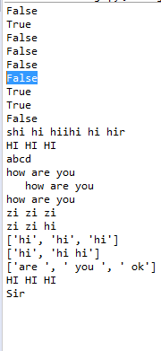

1. Write a program to check whether the string is alphanumeric .  
2. Write a program to check whether the string is alphabetic.  
3. Write a program to check whether the string is only digits.  
4. Write a program to check whether the string is unicode numeric value.  
5. Write a program to check whether the string is whitespace characters.  
6. Write a program to check whether the string is properly "titlecased" .  
7. Write a program to check whether the string is all cased characters are in uppercase.  
8. Write a program to check whether the string is all cased characters are in lowercase.  
9. Write a program to check whether the string is contains only decimal characters.  
10. Write a program to to Merges (concatenates) the string representations of elements in sequence .  
11. Write a program to convert all the characters to lower case.  
12. Write a program to convert all the characters to upper case.  
13. Write a program to remove all the leading whitespace in string.  
14. Write a program to remove all the trailing whitespace in string.  
15. Write a program to remove all the leading & trailing whitespace in string.  
16. Write a program to Replaces all occurrences of old in string with new.  
17. Write a program to Replaces all occurrences of old in string with new at most max occurrences.  
18. Write a program to Splits string according to delimiter passed.  
19. Write a program to Splits string according to delimiter passed and set the maximum spliting count .  
20. Write a program to Splits line into list when \n is given.  
21. Write a program to inverts case for all letters in string.  
22. Write a program to convert the string into title cased string.